FORM C- STUDENT MEDICAL & CONSENT FORM (Please copy back to back)
Student's Name ______________________________ Male / Female DOB_______________
Home Address________________________________________________________________
School______________________________________________________________________
Parent/Guardian Name __________________________ Contact Number:_________________

In case of a medical emergency, every effort will be made to notify carers. In the rare event instance that contact cannot be made, please give authorisation for Qualified Practitioners to administer:
ANAESTHETIC (Please circle) YES / NO BLOOD TRANSFUSION (Please circle) YES / NO
I give permission for school staff to administer one dose of PARACETAMOL as required should my child be suffering from a headache or any mild discomfort (Please circle) YES / NO

Please list any medical history, concerns or special requirements e.g: Heart problems, respiratory problems, allergies, travel sickness, blood pressure, recent operations, epilepsy, diabetes, recent illness, recent operations, drug reactions (eg. Penicillin Allergy), drugs required, phobias, limited swimming ability or other any other things that staff should be aware of (eg. bed wetting, sleep walking)? – (Dietary requirements on back)

Are there any custodial issues that Runaway Bay SLEC staff should be made aware of? Please outline: ___________________________________________________________________________________________
Medicare Number: _________________________ Number of person: _______________Expiry Date_________
General Practitioner’s Name:_____________________________________ Ph: ________________________
Secondary Contact Name:_______________________________________ Ph: _________________________

We aim to capture and share parts of our student’s camp journey on Facebook. Find us at ‘Runaway Bay Sport and Leadership Excellence Centre’
I give permission for photos to be taken of my student for the purpose of sharing to social media
(Please circle) YES / NO

The Queensland Department of Education requires Risk Assessments to be conducted on all curriculum areas that contain potential hazards. At RBSLEC, specific activities (Stand Up Paddle Boarding, Raft Building, Archery, Swimming/Pool Games, Weight based training & Triathlon) are deemed ‘high risk’, while Kayaking is classified as an ‘extreme risk’ activity. To minimise these potential risks, RBSLEC implements strict safety procedures in accordance with the Department’s health and safety guidelines. RBSLEC prides itself on its impeccable safety record with all sessions being facilitated by trained and qualified staff.

I (Name)……………………………………..give permission for my child to participate in adventure-based activities that are considered high or extreme risk by the Department of Education. I understand that at times this may include vehicle transportation to and from learning sites. I hereby authorise the Principal, or their representatives, to obtain such medical attention as may be deemed necessary. I acknowledge that the Department of Education does not have ‘Personal Accident Insurance Cover’ for children/students and I understand that all costs associated with any injury, including medical costs are the responsibility of the parent/carer.

SIGNATURE REQUIRED (Parent / Guardian) ………………………………………… Date …….. / ……./ ……..

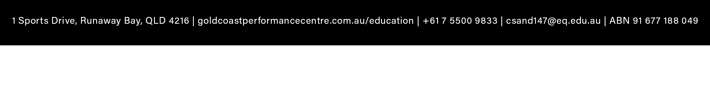
FORM C- STUDENT MEDICAL & CONSENT FORM (CONTINUED)

Detailed Dietary Requirements

Table for food allergies and intolerances only (Not Dislikes):
Full Name: | Peanuts | Tree Nuts | Soy | Fish or Molluscs | Crustacea | Egg | Milk | Wheat or Gluten | Sesame | Lupins | Sulphites

PLEASE ADVISE ANY ANAPHYLACTIC ALLERGIES:________________________________________________________________

Table for special diets:
Full Name: | Vegetarian | Vegan | Halal | Other  (Please Specify)

- I understand that all menu items (including those which have been specially prepared for guests with allergies or intolerances) “may contain” traces of Allergenic Ingredients due to food being processed on equipment and in an environment where all food types are produced.

***NOTE: If the presence of trace allergens is at all a concern, guests will need to bring their own food***

*If a guest fails to advise us of their dietary requirements prior to arrival, we cannot guarantee that a specially prepared meal will be available.

*Guests with food allergies/intolerances will communicate with the chef at the start of each meal service (in conjunction with the teachers).

SIGNATURE REQUIRED (Parent / Guardian) ………………………………………… Date …….. / ……./ ……..

